

A newsletter for employers

City & Guilds Construction
October 2018

A newsletter from City & Guilds on professional and technical education updates in construction for employers.

In this issue:

- Update on government reforms
  - Apprenticeship standards – England
  - T Levels - England
  - Qualifications Wales Review of Construction - Wales
- People Power Research
- News and Policy Media round-up

General Data Protection Regulation (GDPR)
We take your privacy seriously and have updated our privacy policy with information on how your data is stored in line with GDPR.

We wanted to let you know that you will continue to receive this newsletter from us unless you tell us otherwise by contacting us at construction@cityandguilds.com

If you are interested in supporting City & Guilds either as a writer, marker, assessor, or as an EQA please do get in touch with us at construction@cityandguilds.com

For more information regarding the City & Guilds Construction offer, please refer to the Construction – a Summary document on our website:
https://www.cityandguilds.com/qualifications-and-apprenticeships/construction/latest-news-in-construction
Update on government reforms

Apprenticeship standards – England

City & Guilds are currently working with CITB and the employer groups on how best to support the new apprenticeship standards and in becoming an End-point Assessment Organisation.

To check the status of standards currently in development, please visit the government website:
https://www.instituteforapprenticeships.org/apprenticeship-standards/

Standards approved by IfA for delivery so far:
- Carpentry and Joinery
- Advanced Carpentry and Joinery
- Bricklayer
- Plasterer
- Painter and Decorator
- Steel Fixer
- Scaffolder
- Digital Engineering Technician
- Construction Site Engineering Technician
- Surveying technician
- Chartered surveyor (degree)
- Civil engineering technician
- Civil engineer (Degree)
- Civil engineering site management (Degree)
- Geospatial Mapping and Science (Degree)
- Geospatial Survey Technician
- Lifting Technician
- Tunnelling operative

We are closely working with employers and we want to hear from you. Please contact us at construction@cityandguilds.com

For information on how City & Guilds can support your apprentices, please visit:
www.cityandguilds.com/apprenticeships



T Levels – England
Design, Surveying and Planning pathway is currently open for tender for 2020 delivery.
https://www.instituteforapprenticeships.org/about/outline-content-for-first-new-t-levels/


Building Services Engineering and On-site Construction will follow for first delivery in 2021. The Institute for Apprenticeships are now welcoming views on the draft outline content:
https://www.instituteforapprenticeships.org/about/consultation-launches-on-content-for-t-levels/
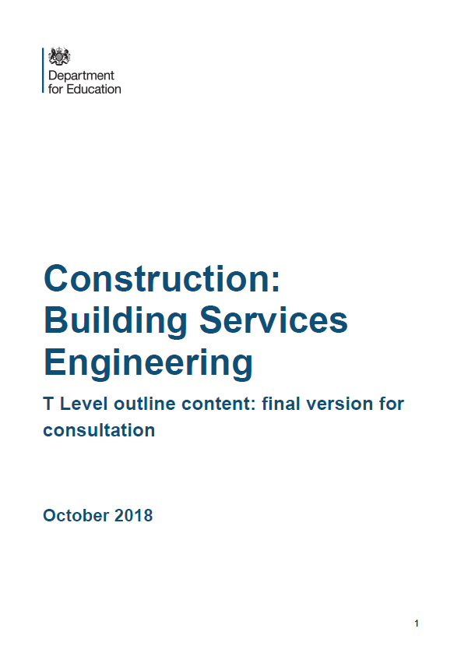

For information T Levels, please visit:
https://www.cityandguilds.com/tlevels
Qualifications Wales Review of Construction

In February 2018, Qualifications Wales published its sector review of qualifications and the qualification system in Construction and the Built Environment.

For the full Building Futures report please visit the Qualifications Wales website:

http://qualificationswales.org/english/qualifications/vocational-qualifications/sector-reviews/construction-and-the-built-environment/

The new qualification system will replace the existing VRQs and NVQs in Wales from September 2021.

The tender for Construction in Wales is expected to be open from November 2018.



Constructing the future
The Work Foundation and the City & Guilds Group share a common interest in understanding the evolution of the workforce and how the skills needed for effective performance in the workplace are changing. Ongoing developments in the world of work put an onus on lifelong learning but are businesses doing enough to upskill their workers and to ensure their effective development and skills utilisation? This paper looks to address these issues through the lens of a particular industry: construction.

http://www.theworkfoundation.com/wp-content/uploads/2018/09/CG_Constructing-the-future_A4_32pp_LR_no-crops.pdf


News and Policy media round-up

DfE - Apprenticeship and levy statistics: October 2018

The Department for Education (DfE) has published statistics covering the latest monthly apprenticeship starts, apprenticeship service registrations and commitments, and apprenticeship levy information.

Starts in July 2018 were down 43% compared with the same month in 2016. 25,200 starts were recorded in July 2018, down from 44,100 in June 2016. Provisional starts for 2017/18 are also down by a quarter on last year (491,300) and 27% on the pre-levy year before (503,700.) However, the July 2018 figures are 21% higher than July 2017 figures, when the levy was newly in use. The ESFA have noted that these figures are not yet final and should be treated with caution.

Skills Minister Anne Milton said in response that the figures show “a growing number of people taking up new, higher quality apprenticeships.” However, Mark Dawe, Chief Executive of the Association of Employment and Learning Providers, has called the figures “disastrous.”

READ MORE ►

DfE - Apprenticeships in England by industry characteristics

Data from the Individualised Learner Record (ILR) and the Inter-Departmental Business Register (IDBR) have been matched.

This allows information about apprentices to be linked to business information about their employers, covering:

- learner characteristics: age and gender
- apprenticeship information: level and subject studied
- employer characteristics: industry sector, size, region and legal status
These experimental statistics relate to the five academic years between 2012 to 2013 and 2016 to 2017. This is the first publication of the 2015 to 2016 and 2016 to 2017 figures.

READ MORE ►

DfE - FE Choices employer satisfaction survey: 2017 to 2018

The survey brings together employers’ perceptions on:
- the quality of the training provided
- the responsiveness of their college or training organisation to the employer’s needs
The scores calculated for each college or training organisation allow for performance comparisons to be made against:
- other colleges and training organisations of the same organisation type
- all the colleges and training organisations which completed the survey and passed the necessary quality thresholds

READ MORE ►

DfE - Annual Priorities letter to the CITB, 2018-19

The Government has priorities for CITB in England for 2018-19:
- Help the construction industry develop the skills it will need to meet the Government’s ambition to build 300,000 homes a year by the mid 2020s, in particular by: analysing future workforce; strengthening the skills partnership with the Home Builders Federation; working more closely with Homes England, housing associations and small and medium-sized developers; and supporting delivery of the National Retraining Scheme Construction Skills Fund.
- Work with the Infrastructure and Projects Authority, procuring Departments, the Construction Leadership Council and industry bodies to plan and deliver the skills and progression routes that will be needed by the construction sector.
- Help the industry adapt to changes in the supply of labour, with a primary focus on increasing apprenticeship numbers to 25,000 per year, developing apprenticeship standards, supporting the development of the new construction T levels and the provision of work placements, considering the implications of the Grenfell Tower disaster, and improving the industry’s record on diversity.

READ MORE ►

DfE - Employer engagement and capacity to support T level placements

This research from the DfE looks to understand what drives existing employer behaviour and examines factors which will influence their future behaviour on T Level work placements. The research explores the motivations behind employers’ provision of existing work-based learning opportunities, and any barriers or challenges they experience in offering these.

READ MORE ►

TES - Damning report calls for overhaul of UTCs

More than half of students in university technical colleges (UTCs) drop out between the ages of 16 and 17, the Education Policy Institute (EPI) has revealed in a “damning” report that calls for their overhaul.
Students who remain beyond age 16 are far less likely to complete their studies than those in other types of school – particularly pupils with lower GCSE results, special educational needs and disadvantaged backgrounds.
UTC students also tend to make less progress than their peers, with only half achieving at least a pass in GCSE English and maths; they also perform poorly in all aspects of the Progress 8 measure, the study finds.

READ MORE ►
TES - Level 2 and 3 apprentices should fill Brexit gap

Fully funding level 2 and 3 apprenticeships for under-25s could help to plug the post-Brexit skills gap, the Association of Employment and Learning Providers (AELP) has said.
The AELP has called on the government to fund apprenticeships for younger people after the “disastrous” fall in starts at lower levels for 16- to 18-year-olds.

The organisation also noted the recommendations of the Migration Advisory Committee’s report, published this week. The AELP said that, if accepted, the proposals would bolster the need for employers to develop home-grown talent.

READ MORE ►

FEI Week - Schools falling short of the new DfE rules on career guidance

Schools are failing to comply with new careers guidance rules, further fuelling concern from FE providers that the Baker clause is being ignored.
Analysis found that the 10 biggest multi-academy trusts in England have not conformed to a new requirement that says all schools should publish detailed careers information online.

READ MORE ►

Wales 247 - University launches new apprenticeships to meet construction growth in Wales

As discussed before The Welsh Government has been keen to see the continued and increased involvement of professional bodies in the promotion of Higher Apprenticeships.
University of Wales Trinity Saint David is delighted to announce two new Higher Apprenticeship programmes in Construction Management and Quantity Surveying.

READ MORE ►

BBC - More Scots 'favouring apprenticeships'

The Bank of Scotland found that the proportion of people who thought on-the-job training or an apprenticeship offered the best career prospects rose from 29% to 32% last year.
Meanwhile, 33% said they believed university remained the best option for their prospects, despite the costs. This was down from two in five (38%) in the previous year.

The bank said cost could be a contributory factor to this "shifting viewpoint", with nearly one in 10 Scots believing that a university education was "no longer financially viable".

READ MORE ►

Tell us what you think
City & Guilds Construction is a newsletter that brings together all of the key developments from City & Guilds relevant to Construction skills learning across England, Scotland, Northern Ireland and Wales. It contains updates on public policy and other information we think you might be interested in.

Each edition is numbered, so we can refer back to previous issues or tell you when information has been superseded.

For specific queries and enquiries please contact our dedicated customer support team: CentreSupport@cityandguilds.com

Meet the team:

 | Ed Shaw  Industry Manager  edward.shaw@cityandguilds.com  02072943314
 | Ian Roberts  Technical Advisor  Ianm.Roberts@cityandguilds.com  07826903967
 | Paul Brown  Technical Advisor  Paul.brown@cityandguilds.com  07872463185

Please follow us on twitter @ConstructionCG

Thank you for your continued support.

Every effort has been made to ensure that the information contained in this publication is true and correct at time of publication. However, City & Guilds products and services are subject to continuous development and improvement, and the right is reserved to change products and services from time to time. City & Guilds cannot accept responsibility for any loss or damage arising from the use of information in this publication.

© 2025 City & Guilds Limited (Reg No 16513878). All rights reserved. City & Guilds is a trademark of City & Guilds Limited.

