
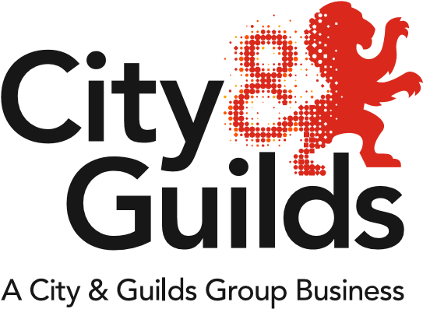
All About Construction
Issue 03
March 2018

A newsletter from City & Guilds on professional and technical education updates in construction for all nations.

In this issue:
  - Extensions and Withdrawals
  - NVQ incremental changes
  - Revised: 5546-60 (601/7375/0) Skills for Working in the Construction Industry
  - Network events
  - Update on government reforms
- Trailblazer Apprenticeship standards – England
- T-Levels - England
- Qualifications Wales Sector Review - Wales

Extensions and Withdrawals
Qualification extensions and withdrawals

The following spreadsheet outlines the extensions for the registration end dates recently requested for the NVQs and Diplomas. Over the next month, Walled Garden will be updated to reflect these new dates:



NVQ incremental changes
As part of the “incremental changes” being made to the NVQs this year, several suites will be given new qualification numbers. For a summary of the changes being made to the NVQs, including new qualification numbers, please refer to our “Summary of NVQ incremental changes” document on the website:
https://www.cityandguilds.com/qualifications-and-apprenticeships/construction/latest-news-in-construction

Further detail of the changes can be found in the updated Qualification Handbooks on the individual product pages.

Centres approved on existing NVQs will be given automatic approval to the replacement.

New qualifications
Revised: 5546-60 (601/7375/0) Skills for Working in the Construction Industry

Our employability skills qualification for the construction industry has been updated to include the Level 1 Award in Health & Safety in a Construction Environment.

Employability Skills make up the majority of this qualification and are fundamental to learners’ first experience of work. The qualification also offers learners an opportunity to learn, develop and practice the basic construction skills and knowledge that are required for employment and/or entry into the construction industry.

By achieving the Health & Safety unit within the qualification, candidates will now be awarded the additional certificate for 6072-51 Level 1 Award in Health & Safety in a Construction Environment. This will qualify learners to apply for the CITB Health, Safety and Environment (HSE) test, required for the CSCS Labourer card, granting access onto a construction site.

https://www.cityandguilds.com/qualifications-and-apprenticeships/skills-for-work-and-life/employability-personal-and-social-development/5546-employability-skills#tab=information

Network events
Please find below further details and joining instructions for our Construction Network Events:

Chichester: 28th March 2018
https://www.eventbrite.co.uk/e/construction-regional-network-chichester-tickets-42899542687

Newcastle: 20th April 2018
https://www.eventbrite.co.uk/e/construction-regional-network-newcastle-tickets-42899127445

Wakefield: 25th April 2018
https://www.eventbrite.co.uk/e/city-guilds-construction-network-wakefield-tickets-41705288641

Glasgow: 1st May 2018
https://www.eventbrite.co.uk/e/construction-regional-network-glasgow-tickets-43339139533

Oxford: 2nd May 2018
https://www.eventbrite.co.uk/e/construction-regional-network-oxford-tickets-42899508585

Aberdeen: 3rd May 2018
https://www.eventbrite.co.uk/e/construction-network-event-aberdeen-tickets-43472039039

Manchester: 5th June 2018
https://www.eventbrite.co.uk/e/construction-regional-network-hopwood-hall-manchester-area-tickets-41874185817

Update on government reforms

Trailblazer Apprenticeship standards – England
To check the status of standards currently in development, please visit the government website:
https://www.instituteforapprenticeships.org/apprenticeship-standards/

Several standards have had recent IfA approvals, including:
- Carpentry & Joinery: approved for delivery
- Advanced Carpentry & Joinery: approved for delivery
- Bricklayer: Assessment Plan approved, but not yet ready for delivery
- Plasterer: Assessment Plan approved, but not yet ready for delivery
- Lifting Technician: approved for delivery

T-Levels - England
The Department for Education are currently reviewing the outputs of the public consultation, which ended on 8th February 2018. For more information regarding T-Levels please visit the City & Guilds webpage:
https://www.cityandguilds.com/tlevels

Qualifications Wales Sector Review - Wales
Qualifications Wales has published its sector review of qualifications and the qualification system in Construction and the Built Environment. For the full Building Futures report and information on how to respond to the consultation please visit the Qualifications Wales website:
http://qualificationswales.org/english/qualifications/vocational-qualifications/sector-reviews/construction-and-the-built-environment/

Public consultation on the sector review ends on 13th April 2018.

Tell us what you think
All About Construction is a newsletter that brings together all of the key developments from City & Guilds relevant to Construction skills learning across England, Scotland, Northern Ireland and Wales. It contains updates on the range of teaching and learning resources we offer, plus relevant public policy or other information we think you might be interested in.

Each edition is numbered, so we can refer back to previous issues or tell you when information has been superseded.

If there’s anything else you’d particularly like us to cover or explain more fully in future issues of All About, please feel free to drop us a line to construction@cityandguilds.com

For specific queries and enquiries please contact our dedicated customer support team: PDCustomerSupport@cityandguilds.com

Meet the team:

 | Ed Shaw  Industry Manager  edward.shaw@cityandguilds.com  02072943314
 | Ian Roberts  Technical Advisor  Ianm.Roberts@cityandguilds.com  07826903967
 | Paul Brown  Technical Advisor  Paul.brown@cityandguilds.com  07872463185

Thank you for your continued support.

Every effort has been made to ensure that the information contained in this publication is true and correct at time of publication. However, City & Guilds products and services are subject to continuous development and improvement, and the right is reserved to change products and services from time to time. City & Guilds cannot accept responsibility for any loss or damage arising from the use of information in this publication.

© 2025 City & Guilds Limited (Reg No 16513878). All rights reserved. City & Guilds is a trademark of City & Guilds Limited.

